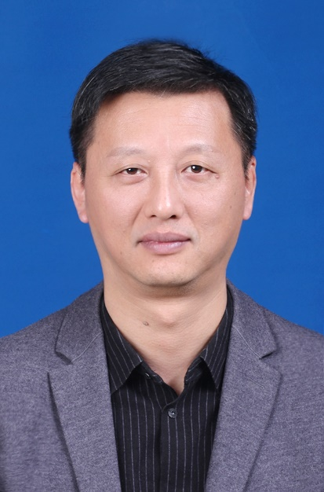 | 邹节新 副教授  南昌大学生物医学测试中心-动物中心 主管  南昌大学基础医学院，硕士生导师
- 教育和工作背景:
1997 江西医学院公共卫生专业 医学学士
2004 南昌大学病原生物学专业 医学硕士
2004-2022 南昌大学基础医学院人体寄生虫学专业教师
2023-至今 南昌大学生物医学测试中心动物中心，硕士生导师
。
- 研究兴趣、领域：
主要研究领域:寄生虫及其宿主动物分子系统地理学，实验动物学。
南昌大学生物医学测试中心动物平台负责人。先后主持完成12项以上寄生虫及其宿主动物地理分布及防制规划等为主要内容的各级科研项目，以第一或通讯作者发表论文30余篇，其中 SCI 收录20余篇，获得教学改革相关软件著作权1项。主持国家自然科学基金 2 项；2017-2023持续主持国家科技基础条件平台项目《国家寄生虫资源库》（子课题）7项；主持完成江西省级教改项目1项，主持完成江西省自然科学基金面上项目、江西省科技支撑计划项目各 1 项。
- 主要成果、荣誉、奖励：
(1) Zhou XJ, Yang Q, Tan QH, Zhang LY, Shi LB, Zou JX*. Paragonimus and its hosts in China: An update [J]. Acta Trop. 2021 Nov; 223:106094. doi: 10.1016/j. actatropica. 2021.106094.
(2) Ning Gao, Ying-Yi Cui, Song-Bo Wang, Jie-Xin Zou*. Two new species and the molecular phylogeography of the freshwater crab genus Bottapotamon (Crustacea: Decapoda: Brachyura: Potamidae) [J]. PeerJ, 2019, 7980: 1-22.
(3) Wang, Song bo, Zhou, Xian min, Zou, Jie xin*. A new species of freshwater crab of the genus Mediapotamon Turkay & Dai, 1997 (Crustacea, Decapoda, Brachyura, Potamidae) from Guizhou, China [J]. ZooKeys, 2019, (873):9-23.
(4) Song-Bo Wang, Chao Huang, Jie-Xin Zou*. Description of A New Species of Freshwater Crab of the Genus Qianguimon Huang, 2018 (Crustacea: Decapoda: Brachyura: Potamidae) from Yulin, Guangxi, Southern China [J]. Zoological Studies, 2019, 58(31).
(5) Zou Jie-xin, Bai Jun, Zhou Xian-min*. A new species of karst-dwelling freshwater crab of the genus Chinapotamon Dai & Naiyanetr, 1994 (Crustacea: Decapoda: Brachyura: Potamidae), from Guizhou, southwest China [J]. PeerJ, 2018, 6: 0- e5947.
(6) Liu, Huimeng, Jiang, Fengjuan, Xu, Shuxin, Zhu, Chunchao, Zhou, Xianmin, Zou, Jiexin*. The complete mitochondrial genome of Aparapotamon similium (Decapoda: Brachyura), an endemic to China [J]. Mitochondrial DNA Part B Resources, 2019, 4(2): 2482-2484.
(7) Ji, Wen Bin, Cui, Ying Yi, Xu, Shu Xin, Jia, Xin Nan, Zhu, Chun Chao, Zhou, Xian Min, Zou, Jie Xin*. The complete mitochondrial genome of the freshwater crab Sinolapotamon patellifer (Decapoda: Brachyura: Potamoidea) [J]. Mitochondrial DNA Part B-Resources, 2019, 4(2):2451-2453.
(8) Yi-Fan Wang, Shu-Xin Xu, Chun-Chao Zhu, Xin-Nan Jia, Xian-Min Zhou & Jie Xin Zou*. The complete mitochondrial genome of the freshwater crab Longpotamon kenliense (Decapoda, Brachyura, Potamidae) with phylogenetic consideration [J]. Crustaceana 2020, 93 (11-12):1277– 1293 DOI:10.1163 /15685403-bja10085.
(9) Songbo Wang, Yifan Wang, Yangjin Zhuoma, Ling Tong, Zongheng Nie, Xinnan Jia, Chunchao Zhu, Xianmin Zhou & Jiexin Zou*. The complete mitochondrial genome of the freshwater crab Potamiscus motuoensis (Decapoda: Brachyura: Potamoidea) [J]. Mitochondrial DNA Part B, 2020, 5:1, 984-985, DOI: 10.1080/ 23802359.2020.1720532
(10) Qi-Hong Tan, Chun-Chao Zhu, Xiao-Juan Zhou, Shu-Xin Xu, Li-Yan-Yang Zhang, Lin-bo Shi & Jie-Xin Zou*. The complete mitochondrial genome of the freshwater crab Neilupotamon xinganense (Decapoda: Brachyura: Potamoidea) [J]. Mitochondrial DNA Part B, 2020, 5:3,2544-2546, DOI: 10.1080/ 23802359. 2020. 1781570
- 联系方式：
电话：（133*****666）
E-mail: （jxzou@ncu.edu.cn）

